Tutorial for Simple Pong

This is a tutorial on how to make a simple pong game in pycharm using pygame.

P.S. This is assuming you already have pycharm and pygame installed. Also I’m using a one I pre-built for this.

## Step 1: Setup

Open pycharm and click on file and create a new project and call it “Simple-Pong”.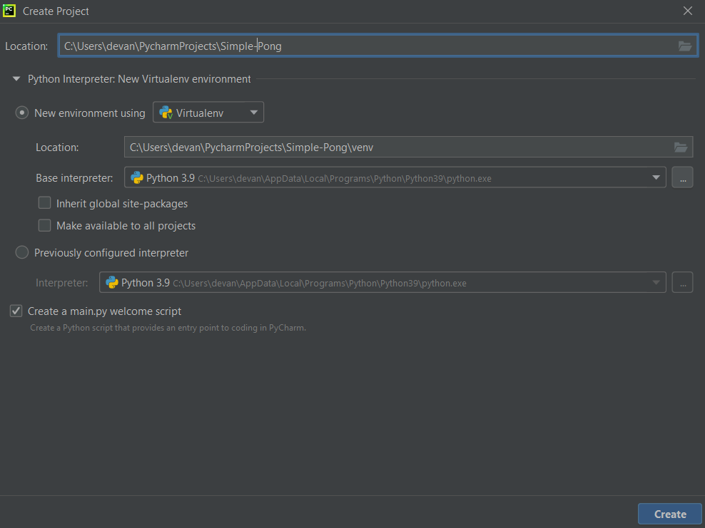

Afterwards you’re going to want to create a new python file and call it settings.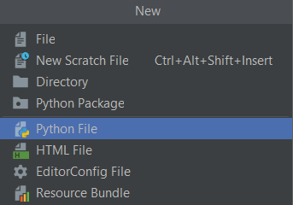

## Step 2: Imports

In your main you’re going to want to import pygame as pg for ease of use, sys, random, and settings.

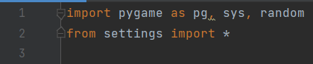

## Step 3: Getting the window

In your main do these lines of code to make a window that appears and can close.

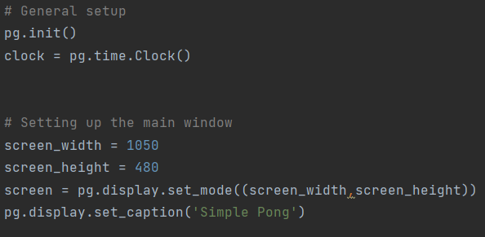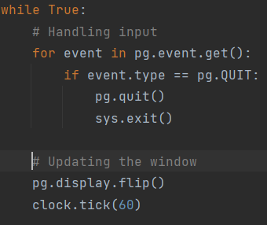

## Step 4: Visuals

In your settings all you need to do is the following line of code.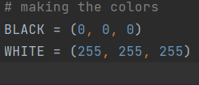

Near your setting up the main window area put in the following code to get the basic sprites and background.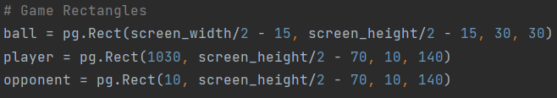

In your main and in your while true, put in the following code to draw the previous code.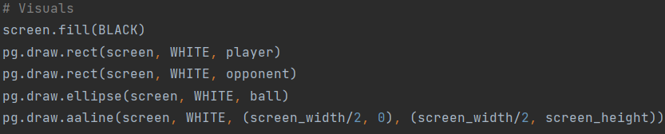

## Step 5: Getting movement

Up towards the top put in the following lines of code.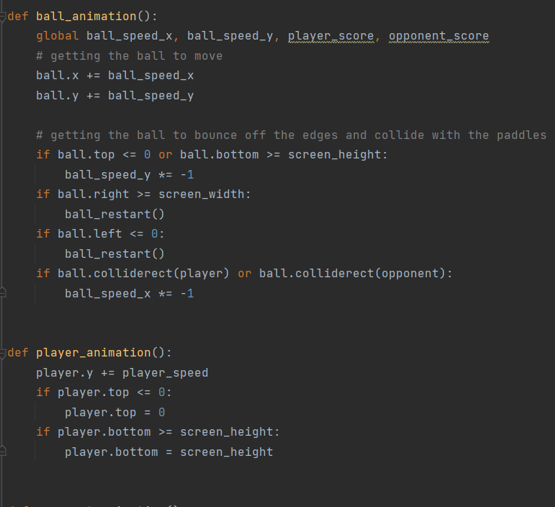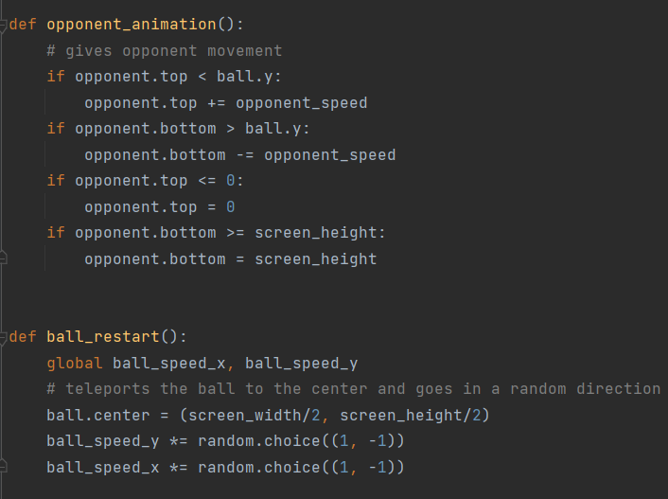

Above your while true, put in these lines of code.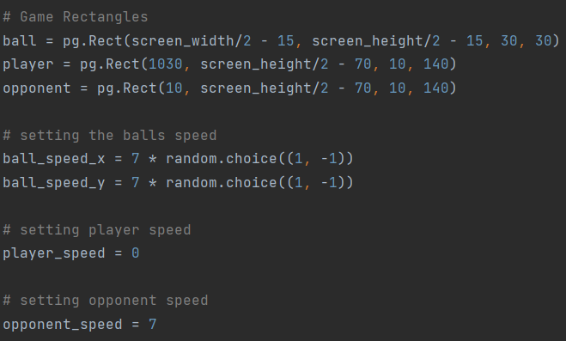

After that put in the code after the quit statement then you’re done.